**What is ADAS Data Annotation?**

**ADAS (Advanced Driver Assistance Systems) data annotation is the process of labeling raw sensor data (camera images, videos, LiDAR point clouds, radar data) so that machine learning and deep learning models can understand the driving environment.**

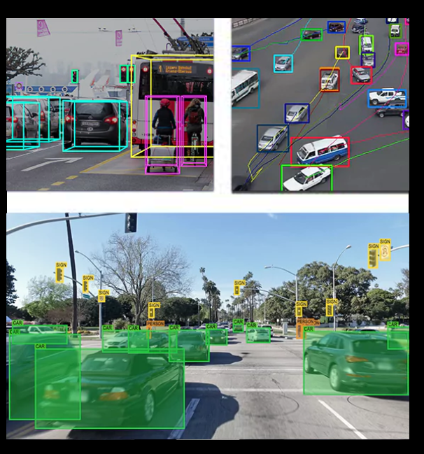

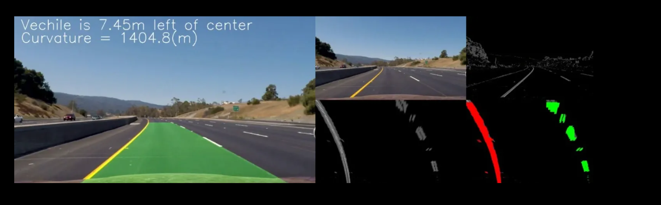

These annotations help vehicles **detect, classify, and track objects** such as:

* Cars
* Pedestrians
* Cyclists
* Lane markings
* Traffic signs
* Traffic lights
* Road boundaries

👉 Without annotation, ADAS systems **cannot learn** how to make driving decisions.

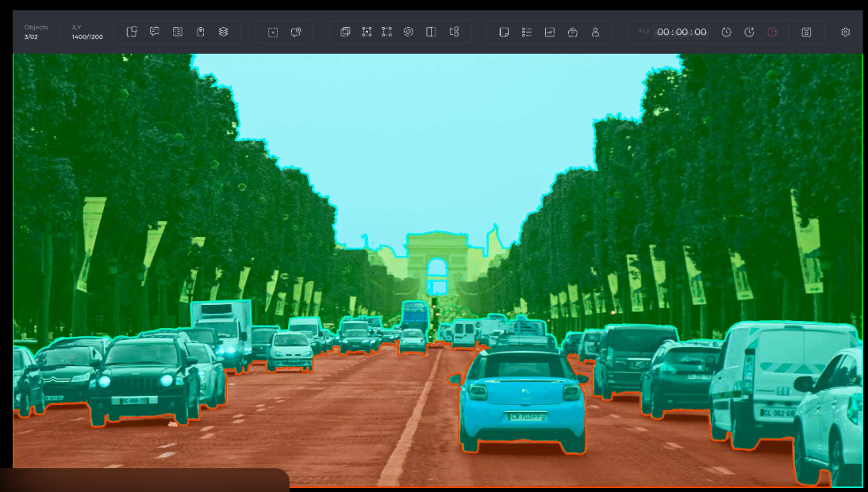

**These annotations help vehicles detect, classify, and track objects such as:**

* **Cars**
* **Pedestrians**
* **Cyclists**
* **Lane markings**
* **Traffic signs**
* **Traffic lights**
* **Road boundaries**

**👉 Without annotation, ADAS systems cannot learn how to make driving decisions.**

**🧠 Types of ADAS Data Annotation (Explained in Detail)**

**1️⃣ Bounding Box Annotation**

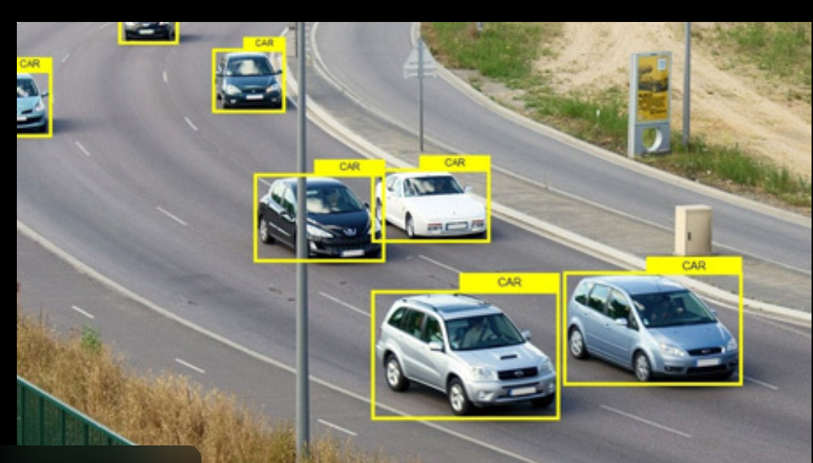

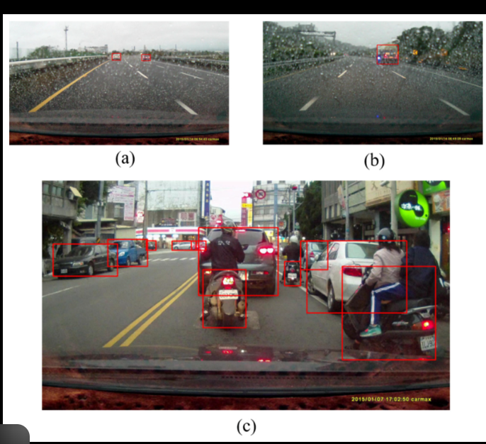

**What it is:  
Rectangular boxes drawn around objects.**

**Used for:**

* **Object detection**
* **Collision avoidance**
* **Pedestrian detection**

**Labeled objects:**

* **Cars, trucks, bikes**
* **Pedestrians**
* **Animals**

**✅ Simple and fast  
❌ Not precise for object shape.**

**2️⃣ Semantic Segmentation**

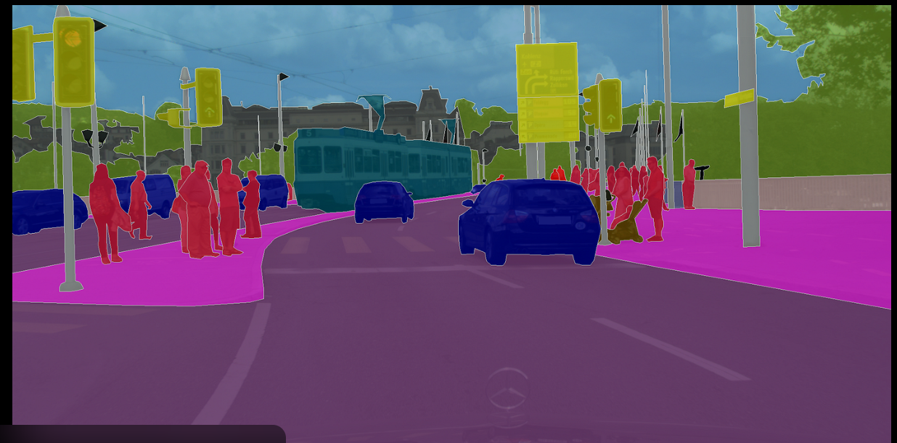

**What it is:  
Each pixel is assigned a class label.**

**Used for:**

* **Road vs sidewalk detection**
* **Lane and curb detection**
* **Drivable area identification**

**Example:**

* **Road = gray**
* **Lane markings = white**
* **Sidewalk = yellow**

**✅ High accuracy  
❌ Time-consuming and costly**

**3️⃣ Instance Segmentation**

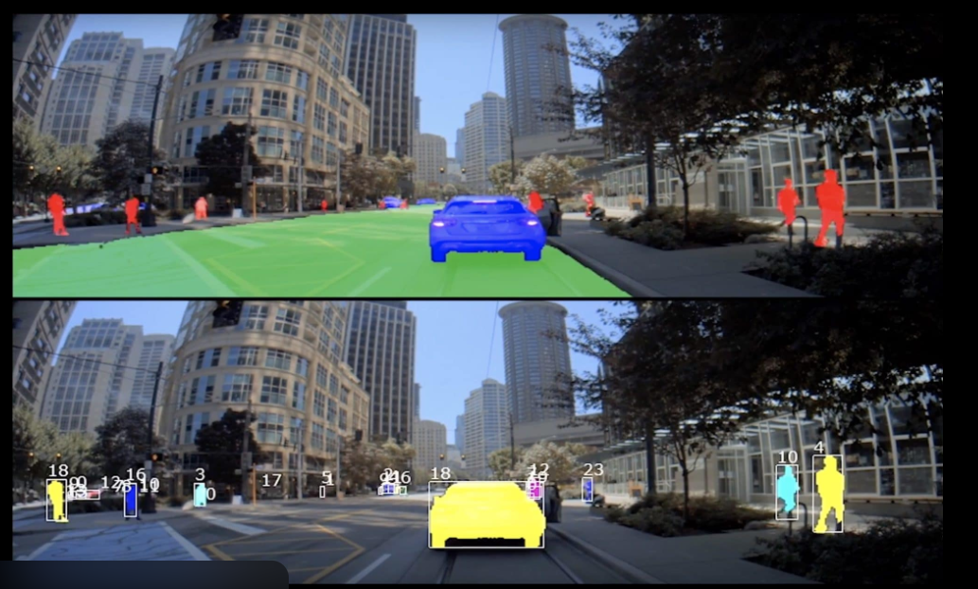

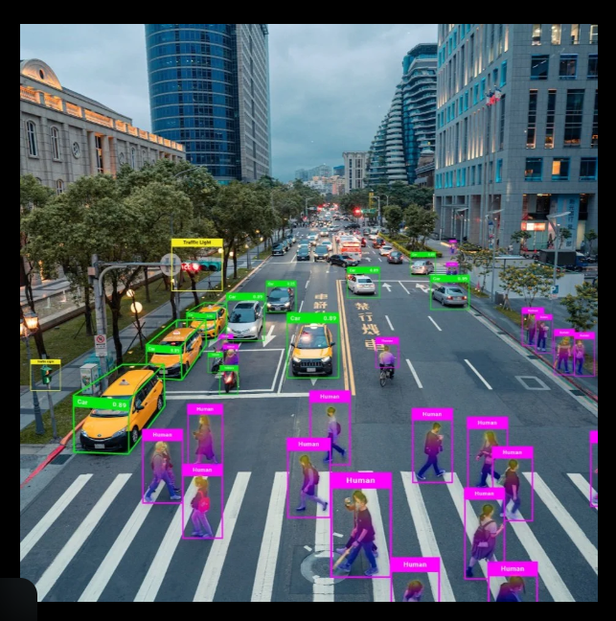

**What it is:  
Pixel-level labeling per object instance.**

**Used for:**

* **Differentiating two nearby cars**
* **Precise obstacle detection**

**✅ Best precision  
❌ Very complex and expensive**

**4️⃣ Lane Annotation**

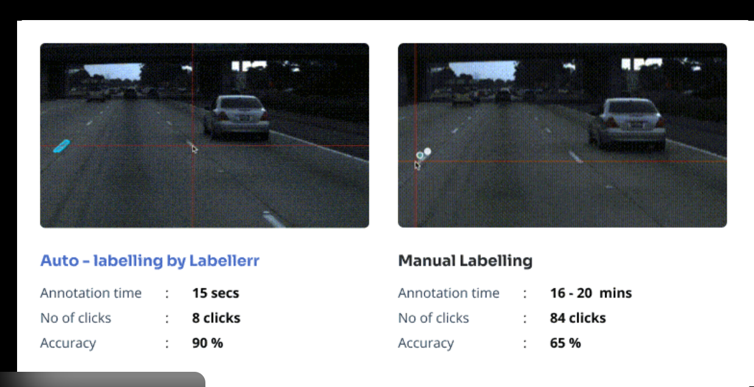

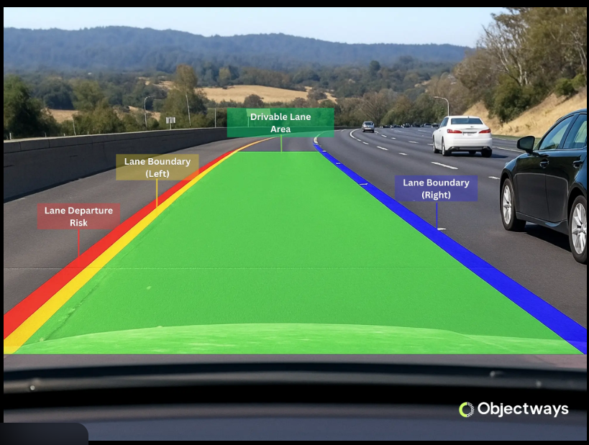

**What it is:  
Annotating lane lines using polylines or splines.**

**Used for:**

* **Lane departure warning**
* **Lane centering systems**

**✅ Critical for highway driving  
❌ Sensitive to poor road markings**

**5️⃣ LiDAR Point Cloud Annotation**

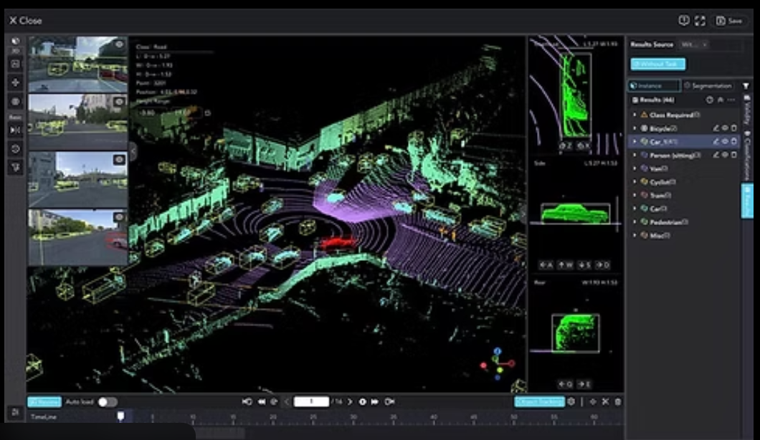

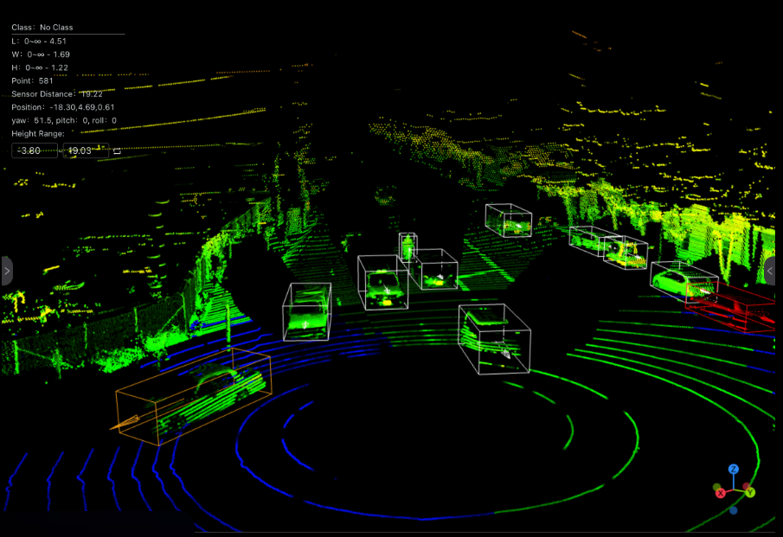

**What it is:  
Labeling 3D data points captured by LiDAR sensors.**

**Used for:**

* **3D object detection**
* **Distance and depth estimation**

**✅ Works in low light & night  
❌ Requires expert annotators**

**6️⃣ Keypoint Annotation**



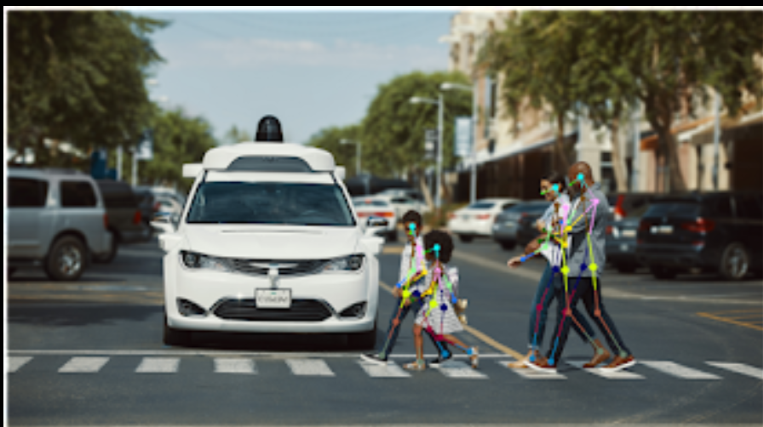

**What it is:  
Marking specific points on objects or humans.**

**Used for:**

* **Pedestrian behavior prediction**
* **Gesture recognition**

**✅ Enables behavior understanding  
❌ High annotation effort**

**🔄 ADAS Annotation Workflow (Step-by-Step)**

**1️⃣ Data Collection**

* **Cameras, LiDAR, radar, GPS**

**2️⃣ Data Pre-processing**

* **Frame extraction, noise removal**

**3️⃣ Annotation**

* **Manual / semi-automated labeling**

**4️⃣ Quality Assurance (QA)**

* **Multi-level validation**
* **Error correction**

**5️⃣ Dataset Delivery**

* **COCO, KITTI, YOLO, PASCAL VOC formats**

**Data annotation is the backbone of machine learning and AI, but in real-life projects it comes with both strong benefits and very real challenges. Below is a practical, experience-based view (what actually happens in companies and projects, not just theory).**

**✅ Advantages of Data Annotation (Real-Life Experience)**

**1️⃣ Improves Model Accuracy (Biggest Advantage)**

**Real life:  
Well-annotated data leads to dramatically better predictions.**

* **In computer vision (face detection, medical imaging), accurate labels can improve accuracy by 20–40%**
* **In NLP (chatbots, sentiment analysis), clear intent labeling reduces wrong responses**

**👉 *Example:*  
Poorly labeled images of “defective products” caused false alarms in production. Re-annotating fixed it.**

**2️⃣ Makes AI Models Understand Context**

**Real life:  
Raw data has no meaning without labels.**

* **Text → intent, sentiment, entities**
* **Images → object type, position**
* **Audio → speaker, emotion**

**👉 *Example:*  
A chatbot failed because “refund status” and “cancel order” were labeled the same. Correct labeling fixed user confusion.**

**3️⃣ Enables Automation in Real Businesses**

**Real life:  
Annotation allows AI to replace or assist manual work.**

* **Healthcare → X-ray analysis**
* **Finance → fraud detection**
* **Retail → product recommendation**

**👉 *Example:*  
Annotated customer tickets helped automate 60% of support queries.**

**4️⃣ Helps Detect Bias Early**

**Real life:  
Annotation exposes imbalanced or biased data.**

* **Gender, race, accent, regional bias**
* **Over-representation of certain classes**

**👉 *Example:*  
A face recognition model failed for darker skin tones due to biased annotations.**

**5️⃣ Essential for Compliance & Safety**

**Real life:  
High-quality annotation is required in regulated industries.**

* **Medical diagnosis**
* **Autonomous vehicles**
* **Banking risk models**

**👉 *Example:*  
Incorrect medical image labeling could lead to wrong diagnosis → legal risk.**

**❌ Disadvantages of Data Annotation (What People Don’t Talk About)**

**1️⃣ Extremely Time-Consuming**

**Real life:  
Annotation takes much longer than expected.**

* **Labeling 10,000 images can take weeks**
* **Complex tasks (medical, legal) take months**

**👉 *Example:*  
Model training took 2 days, annotation took 2 months.**

**2️⃣ High Cost (Hidden Expense)**

**Real life:  
Annotation is expensive.**

* **Manual annotation → paid human labor**
* **Expert annotation → doctors, lawyers, domain experts**

**👉 *Example:*  
Medical image annotation cost more than model development itself.**

**3️⃣ Human Errors & Inconsistency**

**Real life:  
Different annotators label differently.**

* **Fatigue causes mistakes**
* **Interpretation varies**

**👉 *Example:*  
Two annotators labeled the same image differently → model confusion.**

**4️⃣ Difficult to Scale**

**Real life:  
Scaling annotation is hard.**

* **Training new annotators takes time**
* **Quality drops as speed increases**

**👉 *Example:*  
Hiring more annotators increased output but reduced label quality.**

**5️⃣ Ethical & Privacy Issues**

**Real life:  
Sensitive data creates serious concerns.**

* **Personal images, voice, medical records**
* **Data leaks or misuse risks**

**👉 *Example:*  
Voice recordings needed anonymization before annotation.**

**6️⃣ Annotation Bias Affects Model Bias**

**Real life:  
Annotators bring their own assumptions.**

* **Cultural bias**
* **Language bias**
* **Social bias**

**👉 *Example:*  
Sarcasm labeled incorrectly due to cultural misunderstanding.**

**⚖️ Real-World Summary Table**

| **Aspect** | **Advantage** | **Disadvantage** |
| --- | --- | --- |
| **Accuracy** | **Improves model performance** | **Wrong labels hurt badly** |
| **Cost** | **Enables automation** | **Expensive upfront** |
| **Time** | **Speeds future workflows** | **Slow to create** |
| **Bias** | **Can reduce bias** | **Can also introduce bias** |
| **Scaling** | **Supports large AI systems** | **Hard to scale consistently** |

**💡 Practical Industry Insight**

**“Data annotation is not a one-time task. It’s an ongoing process.”**

**In real projects:**

* **Data → annotate → train → test → re-annotate → retrain**
* **60–70% of AI project time is spent on data preparation & labeling**

**.**

**🧩 Key Roles & Responsibilities**

**1️⃣ Data Labeling & Annotation**

* **Annotate images, text, audio, and video data according to project guidelines**
* **Perform tasks such as bounding boxes, classification, segmentation, tagging, and transcription**
* **Ensure high accuracy and consistency across all labeled datasets**

**2️⃣ Data Quality Assurance**

* **Review and validate annotated data to identify errors or inconsistencies**
* **Perform cross-checks and peer reviews to maintain labeling standards**
* **Rework incorrect annotations based on feedback**

**3️⃣ Understanding Project Guidelines**

* **Study and strictly follow annotation instructions and label definitions**
* **Ask clarifying questions when data or rules are ambiguous**
* **Adapt quickly to guideline updates during project iterations**

**4️⃣ Collaboration with ML & Data Teams**

* **Work closely with data scientists, ML engineers, and QA teams**
* **Provide feedback on unclear data patterns or missing labels**
* **Support model improvement by highlighting data issues**

**5️⃣ Tool & Platform Usage**

* **Use annotation tools such as Labelbox, CVAT, V7, SuperAnnotate, or custom internal tools**
* **Track progress and meet daily/weekly annotation targets**
* **Maintain organized datasets and annotation versions**

**6️⃣ Bias Detection & Ethical Handling**

* **Identify potential bias or imbalance in data samples**
* **Handle sensitive or confidential data following privacy and security rules**
* **Ensure ethical labeling practices across diverse datasets**

**7️⃣ Documentation & Reporting**

* **Document labeling decisions and edge cases**
* **Report challenges, anomalies, or unclear samples to project leads**
* **Maintain logs for completed tasks and revisions**

**8️⃣ Continuous Improvement**

* **Improve annotation speed without compromising accuracy**
* **Learn new annotation techniques and tools**
* **Apply feedback to enhance future annotation quality**

**🏢 Resume-Ready Version (Short & Professional)**

**Data Annotator – Roles & Responsibilities**

* **Labeled and validated large-scale datasets for machine learning model training**
* **Ensured data accuracy, consistency, and compliance with annotation standards**
* **Collaborated with ML teams to improve model performance through high-quality data**
* **Used annotation tools to manage workflows and meet project deadlines**
* **Identified data bias, edge cases, and quality issues during annotation**